**Week 10 Homework: Cryptography Homework**

**Riddle #1 – Caesar Cipher**

**Answer: grubern.** 6skd8s

**Riddle #2 – Binary to Text**

**Answer: Gennero.** cy8snd2

**Riddle #3. – openssl**

**Answer: takagi.** ud6s98n



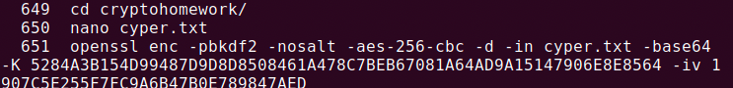



**Riddle #4a and 4b – Public and Private Keys**

**Answer: Jill’s Public Key, Jill’ Private Key, 12 Asymmetric and 15 Symmetric, Alice’s Public Key** 7gsn3nd2

**4a 4b**

**Riddle #5 – hashcat**

**Answer: argyle** ajy39d2







**Riddle #6 – Stenography**

**Answer: mcclane.** 7skahd6

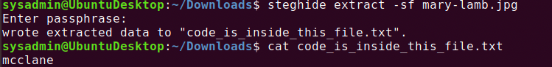

**Ransomware Decrypter – Completed…**

